WI REDISTRICTING REFERENDUM PROJECT
A How-To Guide and Case Study
September 2019

INTRODUCTION

On April 2, 2019, voters in La Crosse County and Vernon County passed an advisory referendum on nonpartisan redistricting by wide margins. The ballot question (“Should the Wisconsin Legislature create a nonpartisan procedure for the preparation of legislative and congressional district plans and maps?”) has now been endorsed by voters in eight Wisconsin counties who believe nonpartisan redistricting reform should be enacted by the Wisconsin Legislature prior to the next redistricting process. Currently a total of 47 county boards, representing 75% of Wisconsin voters, have approved resolutions seeking the same change.

This document is presented as a case study to assist citizens in counties that would like to place the “Fair Maps” referendum on the ballot in a future election. There are four election dates scheduled in Wisconsin for 2020.

The last section of this report includes samples of materials used in the La Crosse and Vernon County effort.

ACKNOWLEDGMENTS

Information in this document was collected by Jack Connelly, of Play Fair Wisconsin, through telephone conversations with individuals involved in the successful referendum effort in La Crosse and Vernon County. Their names and contact information can be found on page 15.

Leslie Wegener, Vernon Friends of Fair Maps, provided extensive editorial assistance.

The League of Women Voters of the La Crosse Area and members of the La Crosse/Vernon Vote Yes Steering Committee are grateful for the guidance and support of the Wisconsin Fair Maps Coalition in their successful redistricting referendum effort. The League of Women Voters of Wisconsin is an active member of the Wisconsin Fair Maps Coalition, a group of 13 organizations collectively working to fight partisan gerrymandering and promote independent redistricting. A full list of coalition members can be found at fairmapswi.com.

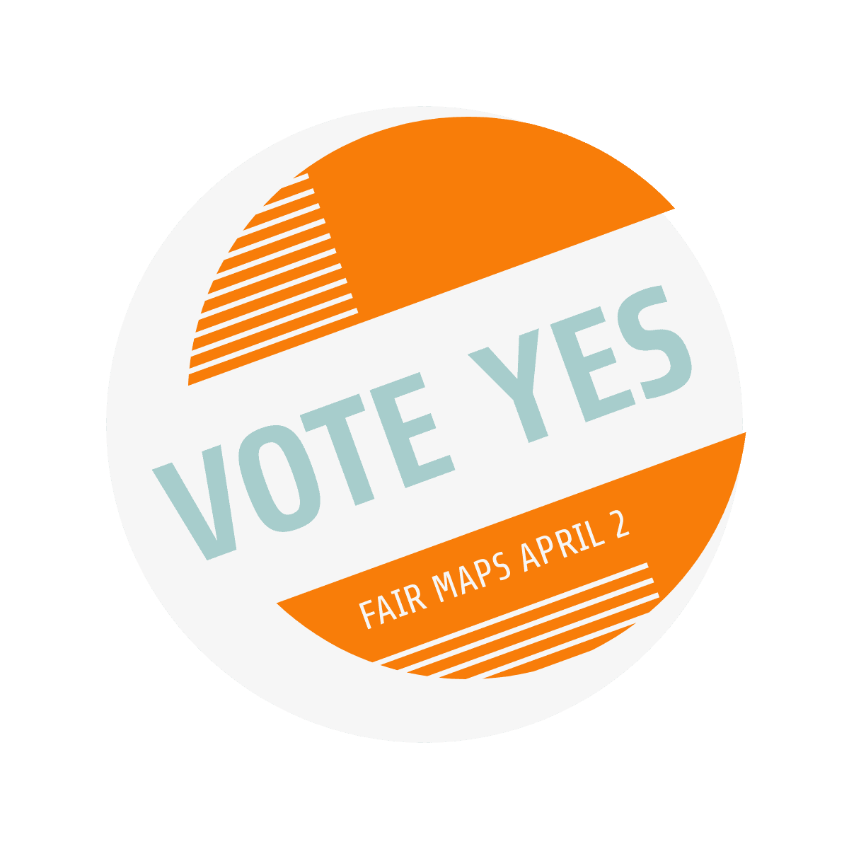
Lessons from La Crosse and Vernon County, Spring 2019

GENERAL CONSIDERATIONS

Overall messaging needed to be inclusive/nonpartisan in order to attract broad support and achieve 70% yes (or better) established by prior county referendums. A majority of Wisconsinites already favor nonpartisan redistricting! Polling by Marquette University indicates that 72 percent of voters prefer redistricting of legislative and congressional districts to be done by a nonpartisan commission. Poll results found majorities in each partisan group favor a nonpartisan redistricting, with 63 percent of Republicans including leaners, 83 percent of Democrats including leaners, and 76 percent of independents favoring a nonpartisan commission.

Another reason to remain nonpartisan: Local nonprofit groups may risk losing their 501c (3) status for engaging in partisan activities.

Be knowledgeable about the arguments against having the referendum put on the ballot, or about redistricting reform itself. Even though the La Crosse and Vernon effort had few people voicing opposition, it’s vital to be prepared to provide informed, well-reasoned counter arguments.

Recognize the time constraints of a collaborative, grassroots process. People are busy, which can extend the timeframe for completing activities such as writing, reviewing and distributing materials, or responding to PR opportunities. Be patient, be flexible, and plan accordingly.

Align your efforts with those of the Wisconsin Fair Maps Coalition. The La Crosse and Vernon effort relied on valuable data from Coalition member organizations (including the Wisconsin Democracy Campaign, League of Women Voters of Wisconsin and Common Cause of Wisconsin) for information presented in the flyers and FAQs they developed. Amy Dummer (Driftless Voter Coalition) acted as primary point of contact with the WIFairMapsCoreGroup, which provided feedback and input on draft flyers, press releases, fact sheets, etc. For a statewide effort to succeed, it’s important to keep Coalition contacts “in the loop” on your progress.

STEP 1: GETTING THE REFERENDUM ON THE BALLOT

Identify referendum committee partners.
Who is going to work with you to advocate for a nonpartisan redistricting referendum?
Reach out to people in your local network, members of Wisconsin’s Fair Maps Coalition organizations, and others interested in this issue. Begin developing the core group that will become your Vote Yes Steering Committee.

The La Crosse and Vernon County effort came together organically.
The League of Women Voters of the La Crosse Area had previously partnered with the Driftless Voter Coalition to help register voters and other Get Out The Vote activities in 2018.
Two Vernon County residents formed the Vernon Friends of Fair Maps group specifically to support passage of the advisory referendum. Overlapping relationships between group members led to a successful collaboration on the two-county nonpartisan redistricting referendum effort.

Review the process.
What are the guidelines your county board follows when it comes to advisory referendums?
Who are your county board members? How are the board committees organized? When do they meet? The county clerk’s office (and/or website) is the best place to start for many of these questions. It’s important to do your research in advance so you can meet key milestone dates. You can view templates for a county-wide Fair Maps advisory referendum and other helpful information in the Wisconsin Fair Maps Coalition’s Ban Gerrymandering Toolkit.

Organizers of the La Crosse and Vernon effort recommend two essential resources:
The County Referendum Process – An In-Depth Primer (Wisconsin Counties Association, February 2018)
Advisory Referendum Petitions Frequently Asked Questions (Wisconsin Election Commission, July 2018)

Target an election date.
When do you want the referendum question to come before voters? Are there advantages to some election dates over others?

Wisconsin requires an advisory referendum to be approved by the full county board and received by the county clerk at least 70 days prior to the election date. Working back from that deadline, you can establish a timeframe for potential election opportunities.

Sample Worksheet for 2020 Elections
When is County Board committee meeting?  (resolution introduction) | When is full County Board meeting? (resolution vote) | -70 days (advisory referendum deadline) | 2020 Election Dates  Elections.wi.gov
 |  | 12/10/2019 | 02/18/2020
 |  | 01/28/2020 | 04/07/2020
 |  | 06/02/2020 | 08/11/2020
 |  | 08/25/2020 | 11/03/2020

Consider which election will give the referendum the best chance of success. General elections typically have a higher voter turnout than primary elections. Statewide races typically draw more voters than local races. It may be helpful to target an election where the referendum would be the only question on the ballot, especially if a second referendum is considered contentious or potentially confusing to voters.

Vernon County Timeline for April 2, 2019 Election

In late November 2018, the referendum idea was favorably received by county board chair Dennis Brault, who introduced the resolution calling for advisory referendum on nonpartisan redistricting on 12/6/2018 (117 days before election.) The enabling resolution was approved at the Legal Affairs Committee meeting on 12/13/2018 (110 days before election) and subsequently approved by the full board on 12/18/2018 (105 days before election.) It was the only referendum on the spring ballot.

La Crosse County Timeline for April 2, 2019 Election

In mid-December 2018, the referendum idea was favorably received by county board chair Tara Johnson and board member Steve Doyle. The resolution calling for advisory referendum on nonpartisan redistricting referendum was proposed and approved at the board’s Executive Committee meeting on 1/9/2019 (83 days before election) and subsequently approved by full board on 1/17/2019 (75 days before election.) It was the only referendum on the spring ballot.

Visualize a campaign strategy.
Requesting an advisory referendum implies a strong interest in seeing the question pass with a resounding YES vote. How do you plan to raise public awareness about the referendum question? How will you inform and persuade voters on the importance of nonpartisan redistricting?

Organizers of the La Crosse and Vernon effort had to work fast.

Referendum supporters in La Crosse and Vernon counties recognized they would have a limited timeframe (3 months/12 weeks) for their public information campaign. The League initiated joint planning discussions in December 2018, before the La Crosse County Board even approved the referendum question. Two working groups emerged – one focused on potential public events and one focused on messaging and fundraising.

A core group of five people (3 League members, 1 Driftless member, 1 Vernon Friends member) did a large portion of the campaign work, functioning as a VOTE YES Steering Committee. Leveraging their individual and organizational strengths, they quickly established a calendar of key dates, an estimated budget for campaign expenses, and a plan for identified public relations opportunities.

Contact county board members.
Does anyone on your referendum committee have a working history or prior relationship with county board members on this or other issues?
Which board member(s) are willing to act as a referendum champion at the county board level? Who will introduce the enabling resolution and help shepherd it through the committee and board meeting process?
Would a public petition help persuade board members of constituent support for an advisory referendum?

Once you’ve identified a point of contact, prepare your “ask” in advance and be specific.
- Provide a sample of the nonpartisan redistricting referendum language adopted in other counties.
- Indicate the election date on which you’d like the advisory referendum to appear on ballot.
- Offer to provide supporting information if needed.
- Offer to speak at committee or board meetings if needed.

Follow up with calls/letters of thanks to the county board members who support putting this advisory referendum question to a vote by their constituents.

The La Crosse and Vernon effort benefited from supportive county board chairs.

One email from referendum advocate Leslie Wegener to county board chair Dennis Brault is what initiated the nonpartisan redistricting question, and subsequent board approval, in Vernon County. Disenchantment with the lame duck legislative session, following the election of Governor Tony Evers, is thought to have played a factor in the board’s deliberations.

In La Crosse County, La Crosse Area League members spoke at committee meetings and stayed in contact with county board chair Tara Johnson to expedite board action on the referendum question before the 70-day-in-advance deadline. The effect of partisan redistricting on local control and decision-making is thought to have played a factor in the board’s deliberations.

In retrospect, La Crosse Area League members suggest including language in the referendum’s enabling resolution that would specifically direct county clerks to notify elected officials at the state or national level of the results of the referendum. Sample language is available upon request.

STEP 2: AFTER REFERENDUM IS ON THE BALLOT

Review referendum committee requirements.
Confirm that your advocacy and promotional efforts will be in compliance with state election laws. In addition, referendum organizing partners working with the League of Women Voters (a nonpartisan, grassroots, political organization) should be briefed on expectations of non-partisanship. Local chapters risk losing their affiliation by engaging in activities deemed partisan.

Establishing partnering guidelines and ground rules is important.

By contacting the Legislative Reference Bureau in Madison, the Vernon and La Crosse organizers were referred to a 2016 document, Campaign Finance Overview: Referendum Committees, produced by the Government Accountability Board. LRB legal staff confirmed that if the committee receives contributions or makes disbursements of less than $10,000, it does not need to be registered with the state. Together and separately, the La Crosse and Vernon County groups operated well below the $10,000 threshold, therefore neither had to register.

To comply with the disclaimer requirement, which states that when a communication is paid for by a committee, the disclaimer must include the words “Paid for by,” followed by the name of the committee, all printed and produced materials included the following disclaimer:

Paid for by the League of Women Voters of the La Crosse Area
and Vernon Friends of Fair Maps

Partnering with a LWV chapter means there will be ongoing discussions about what constitutes partisanship, and what is and is not allowable. The League neither supports nor opposes candidates for office at any level of government. At the same time, the League is wholeheartedly political and works to influence policy through advocacy. Organizers of the La Crosse and Vernon County effort managed to navigate the grey area with minimal misunderstandings, but some degree of oversight and compliance is to be expected.

Launch fundraising & friend-raising appeals.
How do you intend to manage expenses related to your advocacy efforts? Are you aware of referendum supporters who wish to make a monetary contribution, or volunteer their time and/or expertise, to help with your public information campaign? Do any of the partnering organizations have grants or other funding sources available?

Ask an established non-profit nonpartisan partner to act as the fiscal agent. This avoids the need to obtain a new tax I.D. number or having to set up a checking account with a bank or credit union.

La Crosse and Vernon organizers kept it small & simple.

From the outset, the La Crosse League offered to serve as a fiscal agent for the joint referendum effort, having done so previously for collaborative projects with the Driftless Voter Coalition. This arrangement was immensely helpful, as it allowed financial supporters of Vernon Friends of Fair Maps to direct tax-deductible contributions to the League and designate the referendum campaign as the gift’s purpose. Campaign-related expenses (printing flyers, posters, buttons, social media boosts, etc.) were submitted and recorded by the League treasurer, then paid from this budgeted account.

Fundraising activities were limited and informal. Organizers did not opt for online crowdfunding appeals (GoFundMe or similar) nor were businesses approached for contributions.
Various forms of “pass the hat” resulted in contributions that supported the La Crosse and Vernon referendum campaign. Early samples of planned campaign materials – buttons & flyers – helped generate interest, enthusiasm and “buy in” by making the referendum effort tangible.

At their monthly “Lunch and Learn” programs, the La Crosse League briefed membership on the referendum campaign and raised $600 on the spot. They also reached out to absent members who responded with generous donations.

Vernon Friends of Fair Maps functioned on contributions by 10 individuals dedicated to redistricting reform. In addition, their success can be attributed to several key “Friends” who volunteered their time and expertise with social media, graphic design, button production, copywriting, public relations, project management, etc.

Throughout the campaign, at tabling events and other programs, referendum organizers accepted goodwill contributions to offset the cost of literature, buttons and yard signs provided to attendees.

Plan the elements of your referendum campaign.
It helps to define your objectives:
- Increasing awareness of the nonpartisan redistricting issue;
- Promoting upcoming referendum/election date and asking voters to vote yes.

Then start asking what is needed to achieve these goals.

What will be your key message(s) and how will you deliver with clarity and precision?
Are there existing “Fair Maps” materials you can adapt and leverage?
What communication outlets are available in your county, and what will you need to do in order to respond to opportunities? How will you build/sustain awareness and momentum until the day of the referendum?
What will enable you to make an impact across the county to reach a broader audience of voters?
What type of decision-making process is going to work for your group?

Match the scope of your activities to what can be achieved with the people, skills, time and resources available.

Organizers of the La Crosse and Vernon county effort worked from several areas of strength.

First, LWV La Crosse was strongly committed to the issue, has a history of leadership on redistricting reform, a base of supportive members, and an existing organizational/committee structure that could be activated around referendum campaign tasks.

Second, Amy Dummer (Driftless Voter Coalition) already had connections to and relationships with other grassroots Fair Maps groups around the state.

Third, Leslie Wegener (Vernon Friends of Fair Maps) is an experienced writer and PR professional who also provided design and creative services pro bono as a member of the Vote Yes committee.

Two working groups, open to any interested individuals, began meeting in December to brainstorm ideas for the campaign. One group focused on Money and Messaging; the other group focused on Speakers and Events.

The elements of their campaign came together as outlined below, with samples and further information available upon request.

1. Informational materials. Two print pieces were recommended: a tri-fold flyer, and a one-page FAQ sheet that included a call to action. Both were intended to educate voters about Wisconsin’s redistricting process and the need for reform, as well as inspire a Yes vote in April.

2. Promotional materials. Organizers opted for very traditional campaign tools to raise awareness about the April 2 referendum question. These included Vote Yes buttons, posters, stickers, and yard signs.

3. Events. Organizers focused on hosting public programs where guest speakers could present background and expert perspective on the referendum question. Additional outreach and advocacy opportunities, such as meeting directly with community groups and tabling at local events, would also be identified.

4. Social media. Although inexperienced in this area, organizers recognized the advantage of a Facebook presence for reaching potential voters and sharing information about campaign progress.

5. Public relations. Activities in this area included drafting and submitting regular letters to the editor, press releases for media coverage, and securing editorial spots or guest columns.

Determine campaign budget.
What will it cost to do what you want to do in your referendum campaign? Who is going to research and pull together your cost estimates? Are there existing vendor relationships that will help defray expenses by offering non-profit discounts? What type of oversight or approval process will your committee put in place?

La Crosse and Vernon organizers kept it simple.

Basic budget worksheets were prepared by members of the Vote Yes Steering Committee and submitted for review by the Executive Committee of La Crosse League at their February meeting. Separate estimates for Vote Yes campaign elements in Vernon and La Crosse counties identified areas of overlap, such as production of buttons and stickers.

Run on a lean, shoestring budget, the final campaign tally was as follows:

League of Women Voters of the La Crosse Area
Proposed budget: $2,150 (anticipated expenses for the La Crosse County campaign)
Actual expenses: $1,606
Contributions: $1090 to LWV of La Crosse Area designated for the “Fair Maps” campaign.

Vernon Friends of Fair Maps (for Vernon County)
Proposed budget: $815
Actual expenses: $608 (excludes $275 printing cost paid directly by a core group member)
Contributions: $531 through LWV of La Crosse Area; $425 in direct/personal donations by individuals.

Execute the plan.
Once you’ve committed to your campaign plan, how will you follow through on that commitment? To paraphrase a famous film director: Ideas are easy. Everybody has ideas. Execution is all that matters.

A collaborative process means lots of moving parts. How will your group communicate and stay organized? How will you get it all done by Election Day?

La Crosse and Vernon organizers agree: It’s a lot of work, but worth the effort.

The five members of the Vote Yes Steering Committee stayed in touch by phone and email, plus met every other week to review progress and continue working the plan. A shared document on Google Drive helped track campaign activities and who was responsible for what. For the most part, their system worked.

Some reflections on the execution of each campaign element:

1. Informational materials.
Leslie Wegener anticipated the need for a logo to “brand” the Vernon County referendum campaign and created one for free at Shopify.com. Color choice was deliberately neutral (not red, blue or purple) and highly visible. The logo was in place and ready to use when the campaign extended to La Crosse County.

A flyer was designed ASAP to go to print in January as soon as the La Crosse County Board vote had taken place, and was needed immediately at tabling events. Ideally, the Vote Yes Steering Committee would have preferred more time for review and input. Initial print run was 500 flyers for La Crosse County and 500 flyers for Vernon County.

2. Promotional materials.
A shared order of Vote Yes buttons (300) was produced at stickermule.com.

Stickers (750, address label size) were produced at vistaprint.com. LWV has used “I Voted” stickers for years on voting day. Throughout the 2018 Get Out The Vote/Voter registration campaign and in 2019, volunteers found that the stickers have been popular. Young people like to put stickers on their ipads or phones as well.

Posters (larger than standard paper size) were printed and offered to local La Crosse County businesses for posting in public areas.

Yard signs were a hybrid effort. LWV of La Crosse and Driftless Voter Coalition have yard signs that people use in multiple elections. They say “Everyone Vote.” They also have “add-ons” for specific elections that usually just have the election date. For the April 2 election they offered a choice of add-ons that read: “April 2” or “Vote Yes on April 2.” They printed an extra 100 yard signs and offered the two add-ons.

Previously the LWV of the La Crosse Area had approached the La Crosse City Parks Department and the Superintendent of the School District of La Crosse and received permission to place signs encouraging people to vote in the Parks and School grounds prior to each election. They were only allowed to use the non-advocacy message “April 2” add-on in this election.

LWV has found the use in recent elections of "everyone vote" message in yard signs; social media; and other printed messaging is gaining visibility in the community based on individual observations and comments to League members.

Vernon Friends of Fair Maps used donated yard sign frames and printed 70 new signs specifically for the referendum. They opted for quantity over quality, but their low-cost option did not hold up well in the wet, snowy spring weather.

3. Events.
Three public programs were hosted in March to raise public awareness of the April 2 advisory referendum and encourage voter turnout.

Monday March 4 in Holmen (pop 10,000 in La Crosse County)
Location: Holmen Public Library, 6:00 pm
Speakers: Patrick Barlow (La Crosse County Board) & Keith Knutson (Viterbo history prof) subbing for Tim Cullen (WI Fair Elections Project)

Tuesday March 12 in Viroqua (pop 4,500 in Vernon County)
Location: American Legion Tap House, 6:30 pm
Speakers: Jay Heck (Common Cause) & Joe Heim (UW-L emeritus)

Wednesday March 27 in La Crosse (pop 52,000 La Crosse County)
Location: Viterbo University, 7:00 pm
Speakers: Erin Grunze (LWV), Matt Rothschild (WI Democracy Campaign),
Tara Johnson (La Crosse County Board).

Event hosts were: League of Women Voters of the La Crosse Area, Driftless Voter Coalition, Vernon Friends of Fair Maps, Common Cause in Wisconsin, Wisconsin Democracy Campaign, and the Fair Elections Project.

While the programs were promoted via Facebook, traditional press releases, and some community posters, audience turnout (40-50 people) was less than expected. The side benefits of hosting the programs were: keeping the redistricting issue in the news cycle, creating “postable” content for social media, and having a forum for sharing flyers, buttons, stickers, and yard signs with attendees. The Viroqua program was livestreamed on Facebook, where it was also posted for future viewing by the community at large.

Beyond hosted events, referendum organizers sought out opportunities for community engagement by tabling at events (La Crosse Public Library, UW-La Crosse, etc.) and speaking at private gatherings, such as neighborhood association meetings. Public libraries in Vernon County accepted flyers to leave in their public reading rooms.

4. Social media.
Facebook content was managed independently on three different pages. Two existed prior to the referendum campaign: LWV La Crosse and Everyone Vote, sponsored by LWV of La Crosse Area and the Driftless Voter Coalition, and administered by Amy Dummer.

A Vernon Friends of Fair Maps page, administered by Leslie Wegener, was created specifically for the Vote Yes referendum campaign in Vernon County.

Typical posts included articles on redistricting reform proposed by the Governor’s budget, general background information on partisan gerrymandering and the Whitford Supreme Court case, promoting informational programs and speakers, and calls to action. Advertising “boosts” toward the end of the campaign helped bring the Vote Yes message to a broader geographic audience.

The learning curve for those unfamiliar with Facebook should not be underestimated. Content management takes time. It took some effort to determine what comments were constructive and should be engaged with and which were not and may need to be deleted. With a nonpartisan position to maintain, consistent with the LWV and Driftless Voter Coalition, messaging about the referendum campaign focused on positive messaging, facts, and reinforcing the League position on redistricting. At times this became a challenge with multiple, and relatively inexperienced, content managers for each page.

5. Public relations.
LWV of La Crosse has established media contacts (newspaper, radio, TV) which resulted in good coverage by local newspaper, TV and radio.

In theory, submitting Vote Yes letter(s) to the editor on a regular basis was the goal. In practice, this effort fell short. Ideally one person could be tasked with this project by drafting letters, obtaining approval by committee if necessary, and lining up individuals in key areas to personalize and submit.

Try to optimize opportunities for free PR. Ellen Frantz and others appeared on a program for Wisconsin Public Radio. Leslie Wegener made radio appearances in Vernon County. The more people that can be armed with talking points and comfortable with public speaking, the more impact you can have.

P.S If feasible, mailings could add to an effective campaign.
Options for targeted general delivery or bulk postcard mailing were discussed in early brainstorming sessions and might have been a helpful tool for reaching referendum voters. Challenges for La Crosse County included the significant expense of a mailing as well as creating a potential mailing list. Vernon Friends considered a mailing to individuals who had signed petitions supporting the Fair Maps resolution adopted by the Vernon County Board in 2017. (Copies of the petitions can be requested from the county clerk’s office.) In the end, a lack of time and resources precluded any type of mail effort in this campaign.

STEP 3: AFTER REFERENDUM IS PASSED

Plan for success and have a press release written and ready for distribution the morning after election. Include notification of your contacts with the Fair Maps Coalition so referendum news can be leveraged across the state.

If the original enabling resolution by your county board resolution includes a directive for the county clerk to notify elected officials at the state or national level, the clerk’s office will follow through by sending a notice of referendum results. It’s helpful for a member of the steering committee to develop a relationship with the county clerk prior to the election, discuss this directive, and offer volunteers to help transmit the results.

Organizers of the La Crosse and Vernon effort were stretched thin by Election Day.

The sheer scope of work falling to individual members of the steering committee meant consideration of post-election follow up came late in the process. In the rush to the April 2 finish line, preparation/review/approval of the committee’s press release took longer than anticipated, and did not go out until several days after referendum results had already been reported in local media.

The original resolutions adopted by the Vernon and La Crosse County Boards did not include language that directed the county clerk to send public notice of election referendum results to elected officials. Therefore, the responsibility of that additional step was assumed by the Vote Yes Steering Committee, which was unable to complete the task until several weeks after the election.

Copies of the press release, results notification letter, and notification mailing list are available from the La Crosse LWV upon request.

END NOTE: SINCE THE REFERENDUM

June 20 & 21, 2019: Senate Bill 288 and Assembly Bill 303, companion proposals to create a nonpartisan redistricting process, are introduced and referred to committee (SB 288 to Senate Committee on Government Operations, Technology and Consumer Protection; AB 303 to Assembly Committee on Campaigns and Elections.) Authors include La Crosse area Democrats Sen. Jennifer Shilling, 32nd Senate District; Rep. Steve Doyle, 94th Assembly District; and Rep. Jill Billings, 95th Assembly District.

July 15, 2019: Vernon County Rep. Loren Oldenburg, 96th Assembly District, is added as co-author to AB 303, becoming the fourth Republican to sign on to the legislation.

July 16, 2019: Good government groups, the press, and concerned citizens from across the state filled the Assembly parlor room to capacity. The purpose of the gathering was to bring attention to the current legislation and need for redistricting reform in Wisconsin. Erin Grunze, LWVWI executive director, was there to deliver a statement on the importance of the nonpartisan redistricting bills SB 288 and AB 303.

Timeline leading to Spring 2019 Fair Maps Referendum

Aug 2017 | La Crosse County Board approved the “Fair Maps” resolution opposing the partisan redrawing of political district boundaries, commonly known as gerrymandering, and calling for the creation of a nonpartisan procedure for the preparation of legislative and congressional redistricting plans.
Sept 2017 | Vernon County Board approved the “Fair Maps” resolution opposing the partisan redrawing of political district boundaries, commonly known as gerrymandering, and calling for the creation of a nonpartisan procedure for the preparation of legislative and congressional redistricting plans.
Nov 6, 2018 | Election Day. Four Wisconsin counties (Winnebago, Sauk, Eau Claire, and Lincoln) pass advisory referendums on nonpartisan redistricting.
Dec 6, 2018 | Vernon County Board chair introduced a resolution calling for spring advisory referendum on nonpartisan redistricting.
Dec 11, 2018 | LWV of La Crosse Area monthly meeting. Members initiated referendum conversation with guest speakers Tara Johnson and Steve Doyle, of La Crosse County Board.
Dec 13, 2018 | Vernon County Legal Affairs Committee approved the referendum question and referred it to the full board for a vote.
Dec 18, 2018 | Vernon County Board unanimously voted at their regular monthly meeting to place the referendum question on the April 2 ballot.
Jan 9, 2019 | La Crosse County Board’s Executive Committee voted unanimously in favor of resolution to put referendum on April ballot.
Jan 17, 2019 | La Crosse County Board votes to put referendum on April 2 ballot
Jan 22, 2019 | Deadline for Spring 2019 referendum (70 days prior to April 2)
March 4, 2019 | Info Program 1 in Holmen. Guest speakers: Patrick Barlow (La Crosse County Board) & Keith Knutson (Viterbo history prof) subbing for Tim Cullen (WI Fair Elections Project)
March 12, 2019 | Info Program 2 in Viroqua. Guest speakers: Jay Heck (Common Cause) & Joe Heim (UW-L emeritus)
March 27, 2019 | Info Program 3 in La Crosse. Guest speakers: Erin Grunze (LWV), Matt Rothschild (WI Democracy Campaign), Tara Johnson (La Crosse County Board).
April 2, 2019 | Election Day. Two Wisconsin counties (La Crosse and Vernon) pass advisory referendums on nonpartisan redistricting.
April 5, 2019 | LWV issues press release on referendum results
May, 2019 | LWV sends notification letters to state and national elected officials.

Spring 2019 Fair Maps Referendum Contacts

Ellen Frantz | ellen@johnsflaherty.com | Vote Yes Steering Committee - League of Women Voters La Crosse Area
Chris Haskell | cshaskell@gmail.com | Vote Yes Steering Committee - League of Women Voters La Crosse Area
Deborah Lutjen | dlutjen52@gmail.com | Vote Yes Steering Committee - League of Women Voters La Crosse Area
Amy Dummer | amymarie311@gmail.com | Vote Yes Steering Committee - Driftless Voter Coalition
Leslie Wegener | leslie@juniperhillpartners.com | Vote Yes Steering Committee - Vernon Friends of Fair Maps
Tara Johnson | johnson.tara@lacrossecounty.org | Chair, La Crosse County Board
Dennis Brault | dennisrbrault@gmail.com | Chair, Vernon County Board

Spring 2019 Fair Maps Referendum PR/Media Coverage

Letters to the Editor (La Crosse Tribune and Vernon County Broadcaster)

Jan 6, 2019: Vernon Supports Redistricting Reform by Leslie Wegener https://lacrossetribune.com/opinion/letters/leslie-wegener-vernon-plans-vote-on-redistricting-reform/article_4a1d1f59-5d01-54ee-86cf-e8fc0228afa4.html

Jan 25, 2019: Wisconsin Deserves Fair Maps by Sarah Mayer https://lacrossetribune.com/community/vernonbroadcaster/opinion/letter-to-the-editor-wisconsin-deserves-fair-maps/article_8dc67495-31c2-5a34-92dd-23677645bf8e.html

Feb 13, 2019: Vote for Fair Maps by Elizabeth Kruck https://lacrossetribune.com/opinion/letters/elizabeth-kruck-vote-for-fair-maps-representation/article_4f82173f-03e5-5227-9415-932322d263d5.html

Opinion Columns (La Crosse Tribune)

March 22, 2019: Vote to End Gerrymandering by Deborah Lutjen, LWV La Crosse Area
https://lacrossetribune.com/opinion/columnists/deborah-lutjen-vote-to-end-gerrymandering-now/article_83514735-b39e-598c-a0fb-4ab5d091f252.html

March 25, 2019: La Crosse Forum to Discuss Need for Fair Maps by Keith Knutson, Viterbo University
https://lacrossetribune.com/opinion/columnists/keith-knutson-la-crosse-forum-will-discuss-need-for-fair/article_e4d7309c-dad2-517d-862a-978fc1114cd4.html

News Articles (La Crosse Tribune and Vernon County Broadcaster)

Jan. 10, 2019: La Crosse County might have redistricting vote in April
https://lacrossetribune.com/news/local/la-crosse-county-might-have-redistricting-vote-in-april/article_d6032e68-7ede-58e1-9847-527be618e356.html

Jan. 17, 2019: La Crosse County Board OKs redistricting referendum for April ballot
Randy Erickson La Crosse Tribune Jan. 18, 2019
https://lacrossetribune.com/news/local/la-crosse-county-board-oks-redistricting-referendum-for-april-ballot/article_81f8b058-4115-5508-bac5-f4e6ef130b57.html

Feb 26, 2019: Holmen info meeting set on “fair maps” redistricting referendum
https://lacrossetribune.com/news/local/govt-and-politics/holmen-info-meeting-set-on-fair-maps-redistricting-referendum/article_72d40620-a40a-5dc7-874e-926a5187e692.html
Feb. 26, 2019 Randy Erickson La Crosse Tribune

March 5, 2019: Program to be held in Viroqua on nonpartisan redistricting advisory referendums
https://lacrossetribune.com/community/vernonbroadcaster/news/program-to-be-held-in-viroqua-on-nonpartisan-redistricting-advisory/article_2d4c2d81-a2f9-5a63-9325-2c52daa1309b.html

Facebook

March 12, 2019: Viroqua Referendum Information Program, livestreamed by Vernon Reporter
https://www.facebook.com/358366615004697/videos/398342967634430/UzpfSTQyNzgyNjYxNzc1NzQ5NTo0NTAyMjQ0NzU1MTc3MDk/

Local Community Radio

In Vernon County, Leslie Wegener recorded a citizen editorial for WDRT-FM and a series of appearances on the “Hello Neighbor” program on WVRQ-FM.

Wisconsin Public Radio

March 28, 2019: Redistricting referendum discussed on WLSU “Newsmakers” program
Featuring Ellen Frantz, LWV La Crosse; Maureen Freedland, La Crosse County Board; and Bill Feehan, La Crosse County Republican Party
https://www.wpr.org/listen/1428661

April 4, 2019: Election Results – Voters in La Crosse, Vernon Counties Support Nonpartisan Redistricting Referendums
https://www.wpr.org/voters-la-crosse-vernon-counties-support-nonpartisan-redistricting-referendums?fbclid=IwAR2PFUfBPqd74-mFK7fwCx9REGyVRBO6ER2VQoj_dS5MgWdpVaEdfp4rxNY

Sample Campaign Pieces - Spring 2019 Fair Maps Referendum

March event poster
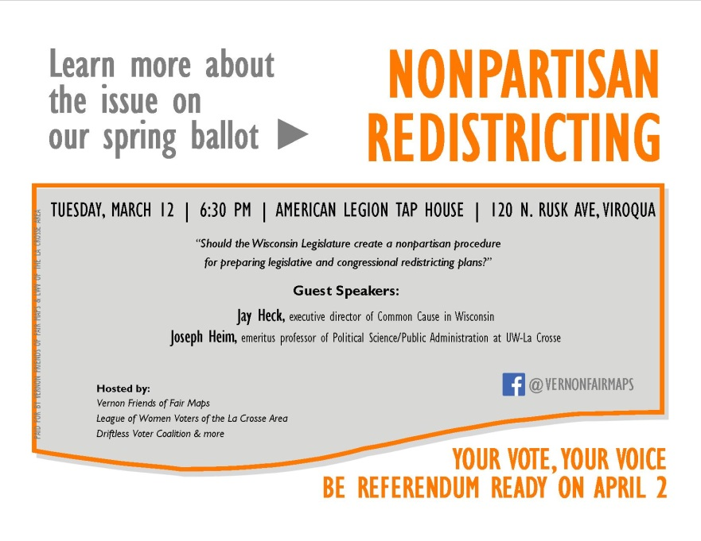

Vernon Friends of Fair Maps Facebook ad
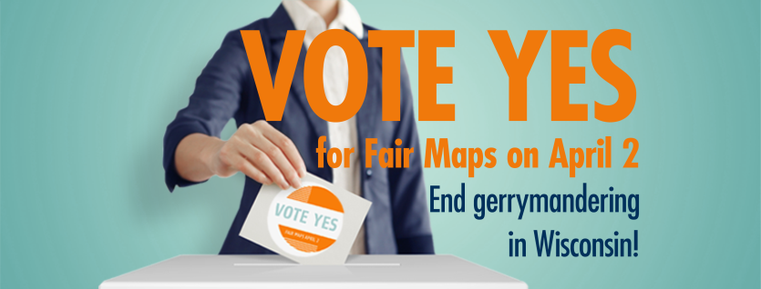

Vernon County yard signs
